PAPER TITLE 16 PT. BOLD, AND CENTERED

Author’s name(s) 12 pt. Bold, Centered
Affiliation, institution and address in 12 pt, bold, italic and centered
Email address(es) 12 pt. Italic and Centered

ABSTRACT

An abstract introducing general layout of the paper with less than 250 words and with 3 keywords should be arranged in the first page of the paper. There should not be page numbering. Maximum number of pages is 10 including the references.

Keywords: Keyword1, Keyword2, Keyword3

MAIN HEADINGS 14 PT BOLD, CENTERED

Official Languages of the symposium is English. Papers should be submitted in English. Papers should be written in Microsoft Word (.docx) format with paper size should be A4 (210 mm x297 mm). Margins should be set to 2,5 cm from top, left, bottom and right of the paper. Texts should be written in 12 pt. “Times New Roman” font style, single spaced and justified.

Sub Headings, 12 pt bold and aligned left

Formulas should be written centred. Each formula should be numbered aligned to right.
(1)

12 pt. Graphic, tables and pictures 12 pt. (Table 1).

Table 1. Lorem ipsum dolor sit amet

Column 1 | Column 2
Lorem | ipsum dolor
Lorem | ipsum dolor
Lorem | ipsum dolor
Lorem | ipsum dolor
Lorem | ipsum dolor

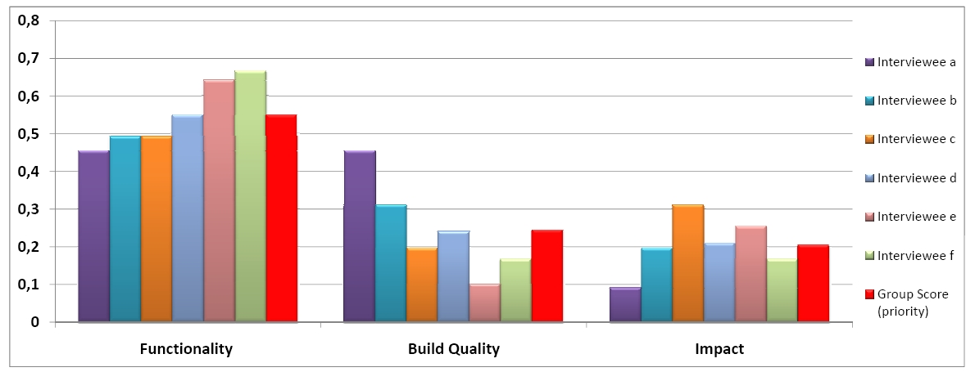

Figure 1. Lorem ipsum dolor sit amet

REFERENCES (APA Style)

Cook M. (2007). The Design Quality Manual: Improving Building Performance, Wiley-Blackwell.

Gann, D. M., Salter, A. J., and Whyte, J. K. (2003). “Design quality indicator as a tool for thinking”, Building Research and Information, Vol. 31, No. 5, pp. 318-333.

Harputlugil, T., and Gültekin A.T. (2006). “Towards increasing the architectural design quality in complex buildings”, International Built and Human Environment Research Week, 3-7 April, Delft University of Technology, Netherlands

Saaty, T.L. (1980). The Analytic Hierarchy Process, McGraw-Hill International, New York, NY, U.S.A.

Saaty, T.L. (1990). The Analytic Hierarchy Process, RWS Publications, Pittsburgh, U.S.A.

Simon, H.A. (1969). The Sciences of the Artificial, The Riverside Press, U.S.A.

